Picture showing Model of A300 Aft Reaction System (looking from the rear). 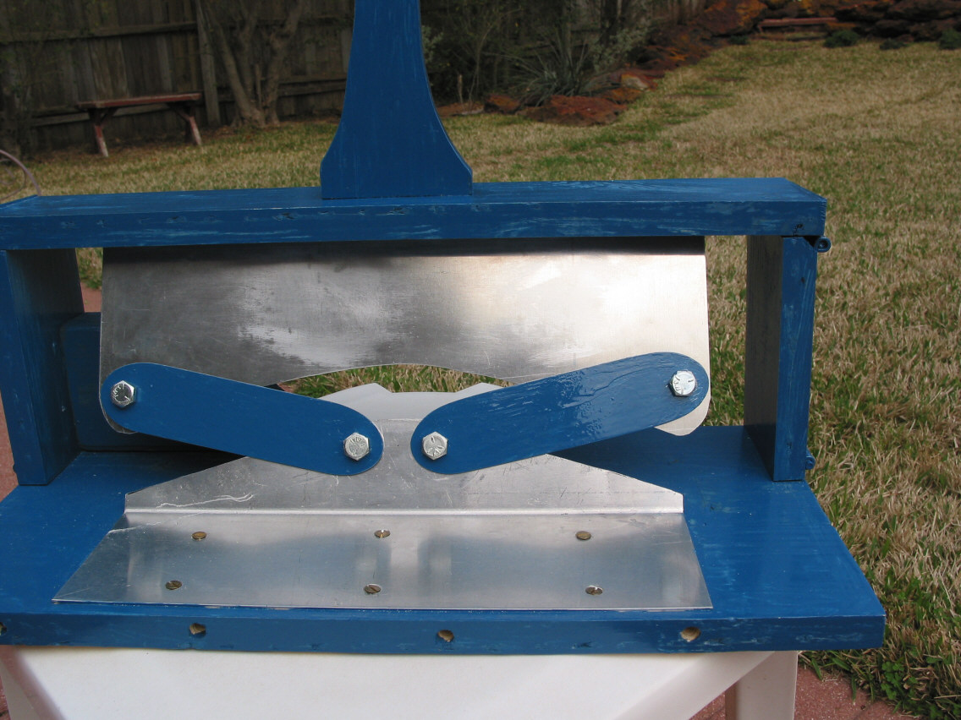
LHS Main Lug
RHS Main Lug
RHS Yoke
LHS Yoke
Rear Spar Web
Fuselage Support Structure

Picture shows Model of A300 Aft Reaction System looking from the rear and right.

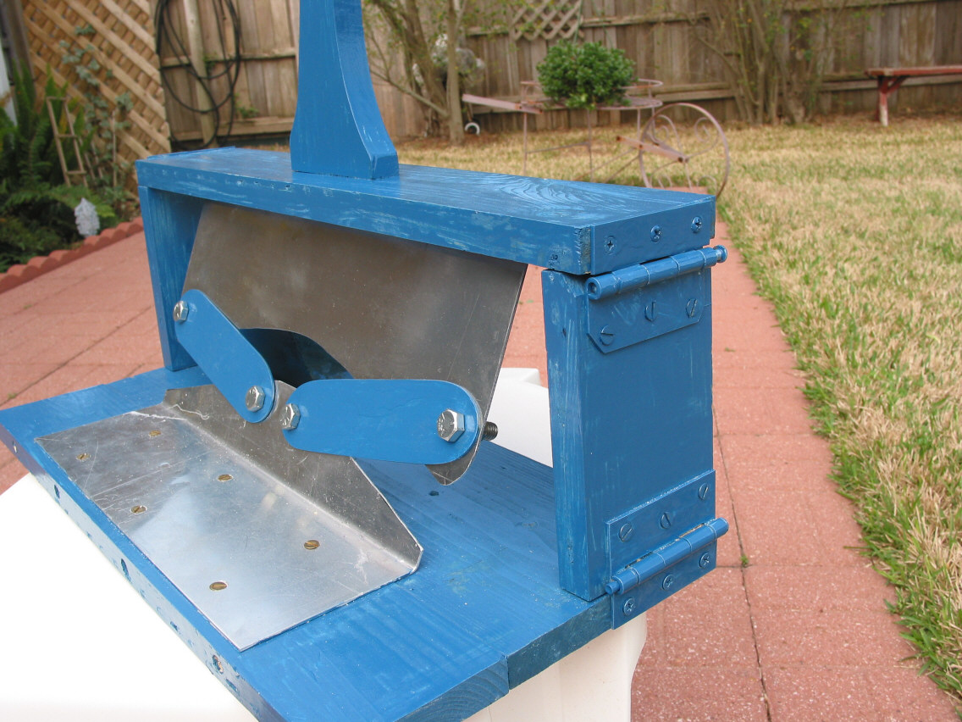

This picture demonstrates that structural capacity in the system still exists with the RHS Main Lug disconnected. As RHS deflects the Yokes provide alternate load path for Roll Moment on the Vertical Tail.

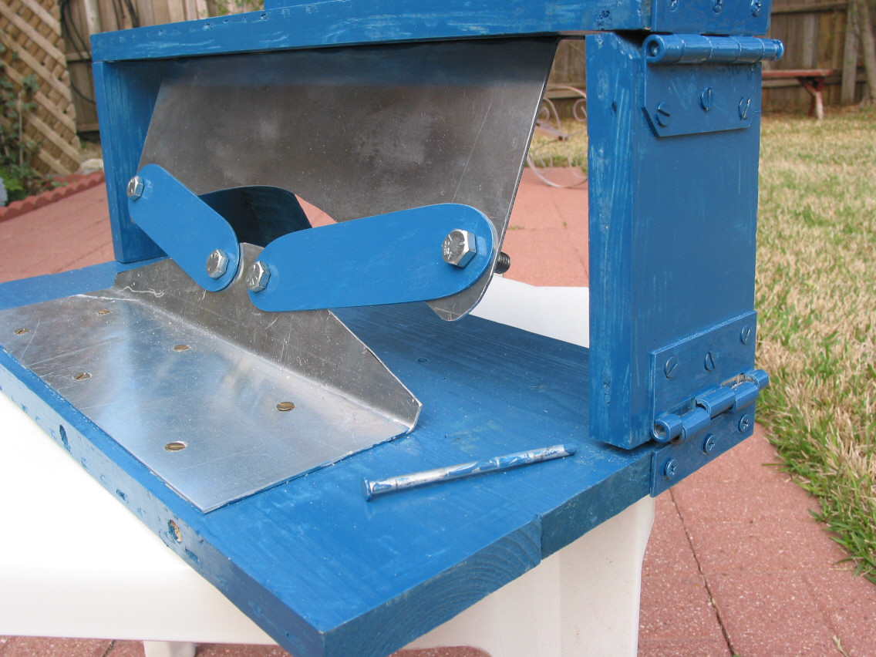
RHS Main Lug
Disconnected
Roll Moment reacted by Yokes

This picture indicates the amount of deflection at the RHS Main Lug that the Rear Reaction System must absorbed in order to maintain Failsafe Criteria.
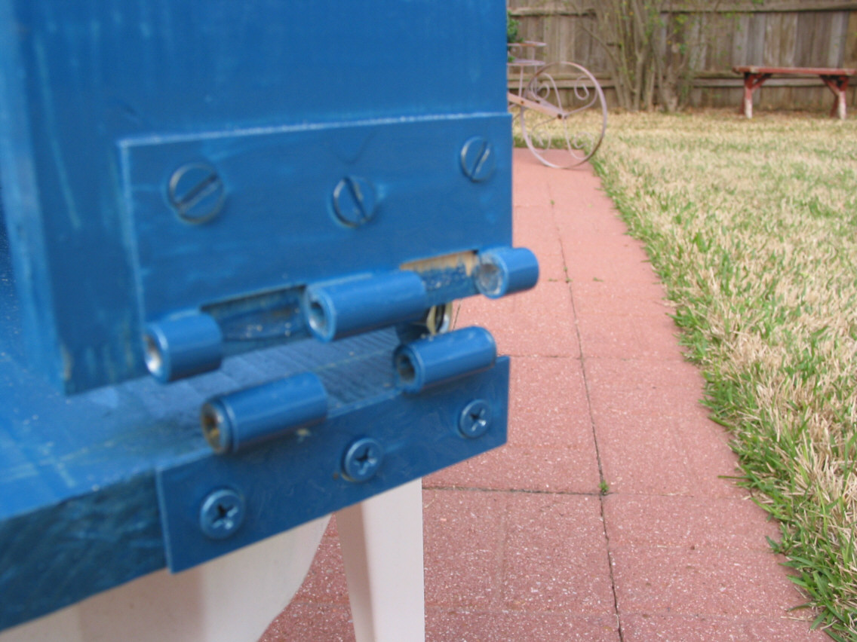
.480 inch Up
.037 inch Outboard

The following two pictures show shadowed areas that represent where the reaction systems would deflect if unrestrained.
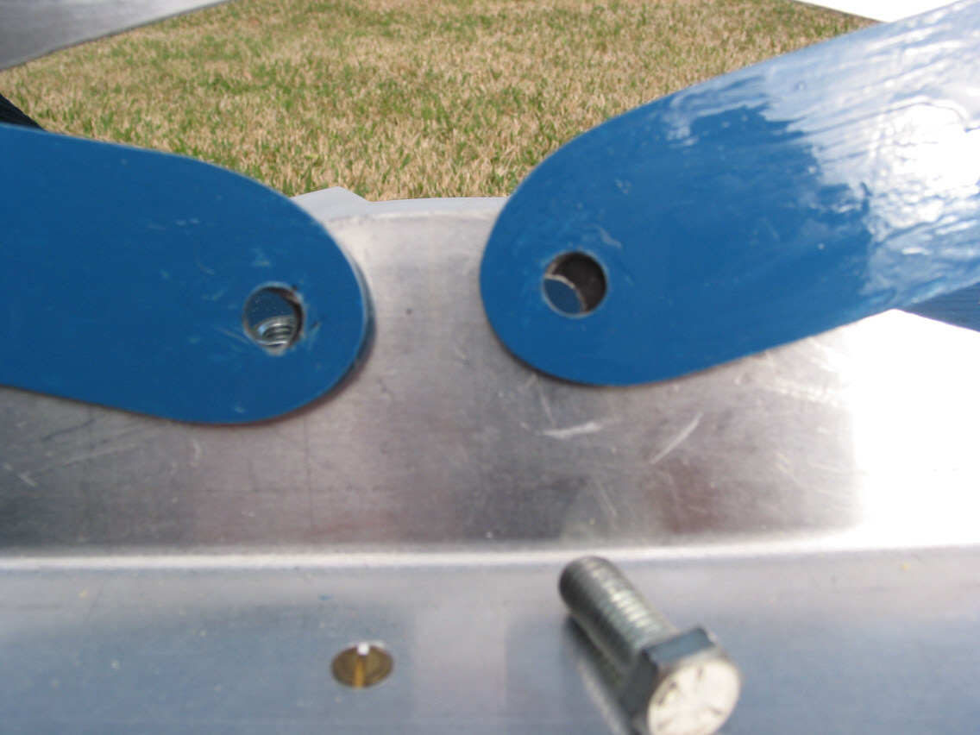
Shadowed Area
Since the yokes are attached to support the Failsafe Criteria, these deflections are absorbed by the yokes and surrounding structural. Deflection is converted into strain energy in the system, much like a spring under deflection, and produces internal loads in the reaction system. 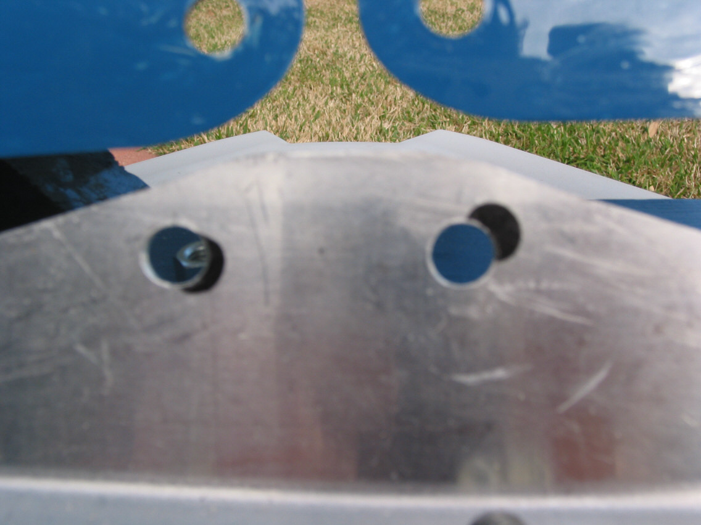
Shadowed Area
Yokes moved out of the way for clarity.
Note the significant lateral deflection to the right that the system must absorb. It’s this lateral deflection component that develops the large additional internal loads in the Yokes and LHS Main Lug.

Also of significance is that this motion develops compression in the LHS Yoke and large tension load in the RHS Yoke. This disagrees with the Airbus FEM that produces a large tension load in the LHS Yoke. Which is correct?

This picture shows the system completely unrestrained and allowed to rotate about the fulcrum, both yokes and one main lug disconnected.

